**Instruction to use the Tool to label the images**

1. Requirement

Use Matlab to write a program to label the images.

In this process, we need to get the coordinate (x, y) of 14 parts of people’s body in the images. The body parts are right ankle, right knee, right hip, left hip, left knee, left ankle, right wrist, right elbow, right shoulder, left shoulder, left elbow, left wrist, neck, head top.

In addition, I need to record the information about people’s direction and sides. Here, direction means direction of the head to feet in the image. Two options: up to down (vertical), left to right (horizontal).Regrading with the lying direction, there are three options: lying flat, lying to left, lying to left.

1. Program

Here, I use the GUI of Matlab to finish the program.

Title: Tool.m, Tool.fig

1. Ways and instruction to use the program

(1). Open the tool.m, execute the program. Then, a gui window will show.

(2). To label all the images easily, press the button, ‘Preprocess’, which help us to rename all the images to new names, like: 0000001.jpg, 0000002.jpg…

(3). After preprocess all the images, click the button ‘Open Image’, then choose a image. The image will show in another window. The name and size will show in the GUI.

(4). If head is up in the image, just use mouse to click the 14 joints. We need to click them in the order. The following table shows the order.

|  |  |  |  |  |  |  |  |  |  |  |  |  |  |
| --- | --- | --- | --- | --- | --- | --- | --- | --- | --- | --- | --- | --- | --- |
| 1 | 2 | 3 | 4 | 5 | 6 | 7 | 8 | 9 | 10 | 11 | 12 | 13 | 14 |
| Right  ankle | Right  knee | Right  hip | Left  hip | Left  knee | Left  ankle | Right  wrist | Right  elbow | Right  shoulder | Left  shoulder | Left  elbow | Left  wrist | Neck | Head  top |

(4). If foot is up in the image, press the button ‘Rotate’ to rotate the image by 180 degrees. Then, repeat (4).

① It may be useful when clicking the 14 joints. Here, the person and me are face to face.

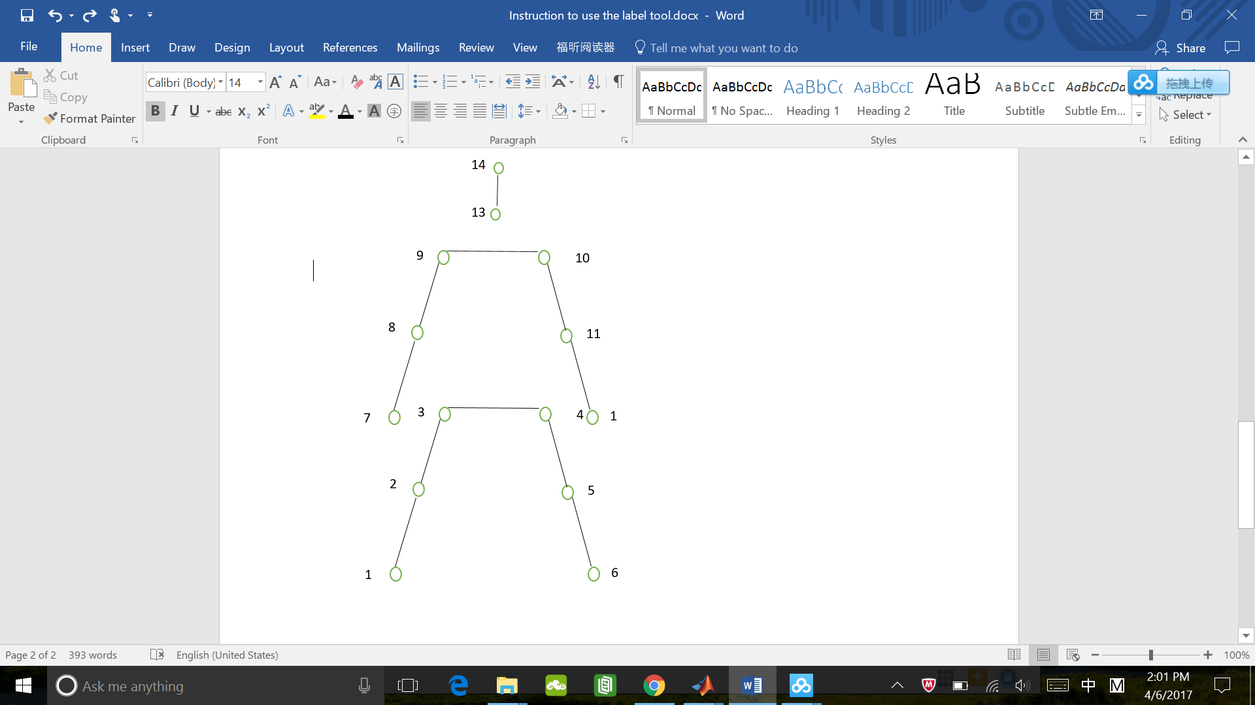

② If we find click mistakes before 14th click, just close the image, open the same image to repeat the steps above.

③ After finish the 14 clicks, all the information will be saved to a $3×16×N$ mat file. In the $3×16$ matrix, the first 14 columns represent the 14 parts. The 3rd row of the first 14 columns represents visibility. Besides, the 16th column represents the information of lying direction. For this column, the useful information is only saved in the 3th row. The 15th column is ready to be used to save the information of direction from head to foot, but it is not used here.

⑤When finishing clicks, some lines will show. Just like.

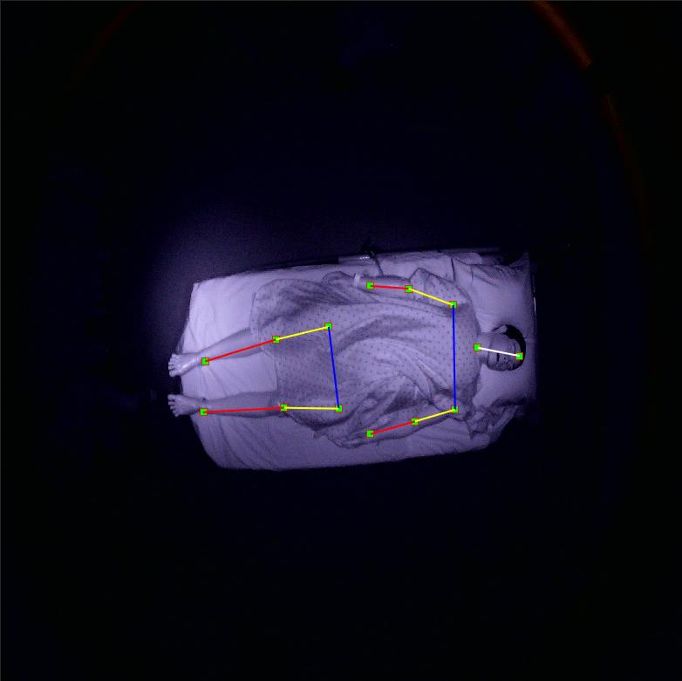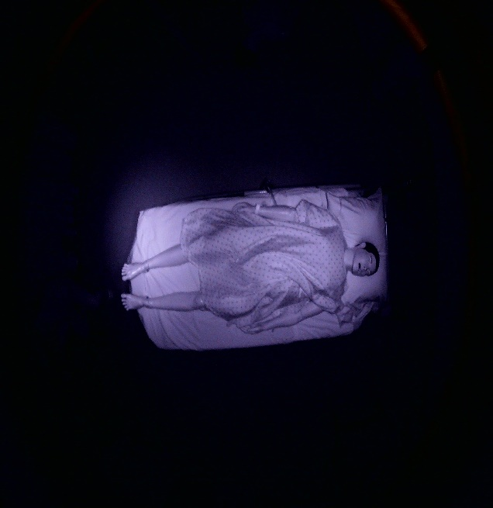

Original image Labeled image

(5). After finishing 14 clicks, we need to add some information to the data. About visibility, 1 means invisible, 0 means visible. If you think some parts are invisible, just input 1 in the corresponding position. About the lie direction, 1 means lying to left, 2 means lying to right. At the beginning, all the values are set as 0.

(6). After finishing all the work above, click button “Save Image”, the labeled image will be saved in the folder, whose name has ‘_Labeled’. Now, users finish labeling one image.

(7). Repeat all the steps above to label many images.

(8). If we close the GUI before finishing labeling all the images in a folder, the corresponding data will save to the file Data_3d.mat, which should be show in the same folder of the GUI. Then, we just need to open the GUI again to label the rest images, the new data will be saved the mat file again without losing the old data. However, we need to save the mat.file to another folder to avoid being covered if we want to label other images in a different folder.

(9). If we finish labeling all the images, we can press the button ‘Check’ to choose a image to get a folder, it will draw the lines in all images of that folder. Then, all the checked images will be saved in the folder, whose name has ‘_Checked’. If all the labeling data are right, the checked images will be the same as the labeled images.

1. Questions
2. . how to define the ‘invisible’ parts: I think the part is visible if it is highly possible for the part to be in a small area. Otherwise, invisible.

(2). When using button ‘Rotate’, the window showing the figure which is need to be rotated will close, then, the error messages may show in the command line of Matlab. The reason for this may be that I use the function ‘ginput’ of Matlab, but it doesn’t affect the real use. To solve this problem, I may need to change the function of ‘ginput’, which is not good.

(3). I wrote the code in windows and I have not tested in Macbook, so there may be some problems in Macbook.